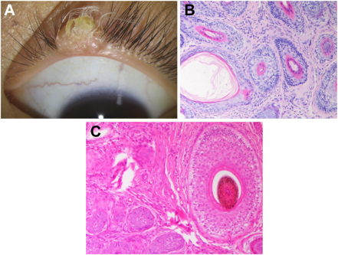

A 6-year-old girl presented with a slowly growing painless swelling on the left upper eyelid margin since birth. Slit-lamp examinationrevealed a fleshy nodule with an umbilicated central depression, and (A) there was a protruded hair tuft composed of approximately 10 hairsfrom the nodule. The patient’s parents said that they had cut the hairs many times, but the hair tuft would recur soon after removal. Thenodule was completely removed.Based on the provided images and clinical description please make an ophthalmic diagnosis for this patient. And output the diagnostic conclusions only.

**Dermoid choristoma**